
Work Instruction for RDM Disk Mapping to a Virtual Machine

Viatris
Work Instruction for
RDM Disk Mapping to a
Virtual Machine

Contents
Contents 2
1. Introduction 3
1.1. Purpose 3
1.2. Scope of this Report 3
1.3. Audience 3
2. Approach and Methodology 3
2.1. Approach 3
2.2. Methodology 3
2.2.1. Validation & Pre-checks 3
2.2.2. LUN Provisioning and ESXi Visibility 4
2.2.3. Mapping RDM to the VM 4
2.2.4. Disk Detection and OS-Level Configuration 4
2.2.5. Post-Implementation Validation 4
2.2.6. Documentation and Compliance 4
2.2.7. Rollback Plan 5
3. Technical Details 5
3.1. Validate LUN Visibility from ESXi 5
3.2. Map the RDM Disk to the VM (vCenter) 5
4. Roles and Responsibilities 9
5. Escalation Matrix 9
6. Revision History 10

1. Introduction

1.1. Purpose
This document will provide the procedure to be followed for adding RDM Disk Mapping to a Virtual Machine based on the requirement.

1.2. Scope of this Report
The purpose of this guide is to provide details on adding RDM Disk Mapping to a Virtual Machine.

1.3. Audience
GIDC UNIX Group

2. Approach and Methodology

Approach
- Identify and confirm the required LUN to be mapped as RDM.
- Ensure LUN visibility to the ESXi host.
- Use vSphere to attach the LUN as an RDM disk to the target VM.
- Rescan within the guest OS and configure it accordingly.

Methodology

2.2.1. Validation & Pre-checks
- Create and document a CR in ServiceNow with all relevant details and obtain approvals.
- Backup current configuration.

2.2.2. LUN Provisioning and ESXi Visibility
The storage team provisions the required LUN and presents it to the target ESXi host or cluster where the RHEL VM resides. The VMware administrator then validates that the LUN is visible on the host, using its unique identifier (e.g., NAA ID) to ensure it is not already in use or mapped to another VM.

2.2.3. Mapping RDM to the VM
After validation, the LUN is attached to the RHEL virtual machine as an RDM disk using the vCenter interface.

2.2.4. Disk Detection and OS-Level Configuration
Once the RDM disk is mapped, the RHEL VM is powered on. The operating system detects the new device upon boot or through a manual rescan. The disk is then initialized as required — this could involve formatting the disk with a filesystem, adding it to LVM, or mounting it to a specified directory. Proper labels and persistent mount entries are configured to ensure consistent access across reboots.

2.2.5. Post-Implementation Validation
The final phase involves validating that the new disk is properly detected, accessible, and mounted within the OS. Logs are reviewed for any errors or warnings.

2.2.6. Documentation and Compliance
1. Document the implementation process with detailed steps, commands, and screenshots where applicable.
2. Ensure compliance with organizational change management and auditing requirements.

2.2.7. Rollback Plan
Maintain a clear rollback plan to remove the RDM disks from the VM if required.

Technical Details
This section outlines the exact technical steps involved in mapping a Raw Device Mapping (RDM) disk to a RHEL virtual machine and configuring it within the OS.

Validate LUN Visibility from ESXi
- Share the WWPN number of the ESXi hosts and inform the Storage team to allocate the LUN to the hosts in the vCenter cluster
- Ensure the LUN is visible on the ESXi host.

Map the RDM Disk to the VM (vCenter)
- Login to the Vcenter with sadm account and password
- Open the VM in vCenter.
- Rescan the storage on the provisioned cluster or the hosts
- Go to Edit Settings → Add New Device → RDM Disk.
- Select the correct LUN (based on NAA ID).
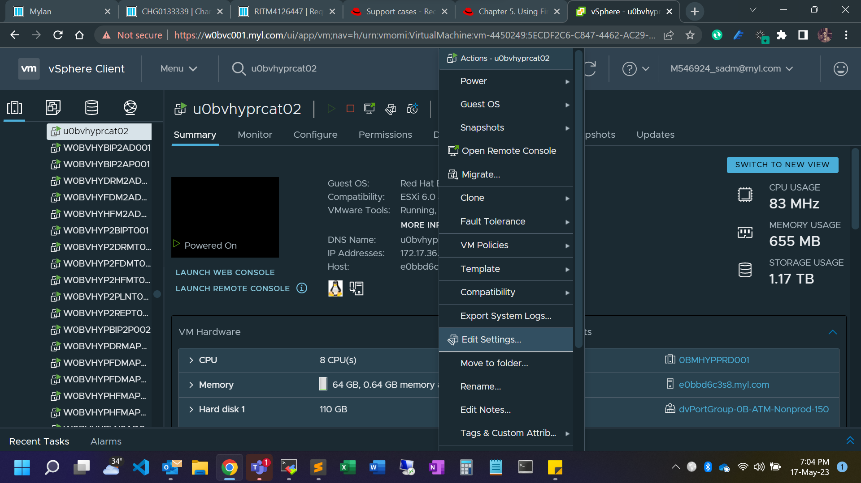
- Select ‘RDM disk’ option to map the LUN to the VM
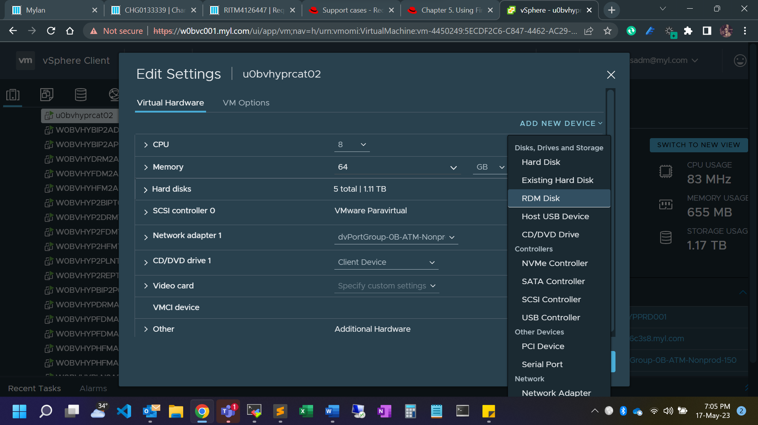

- Select the appropriate LUN to map to the VM
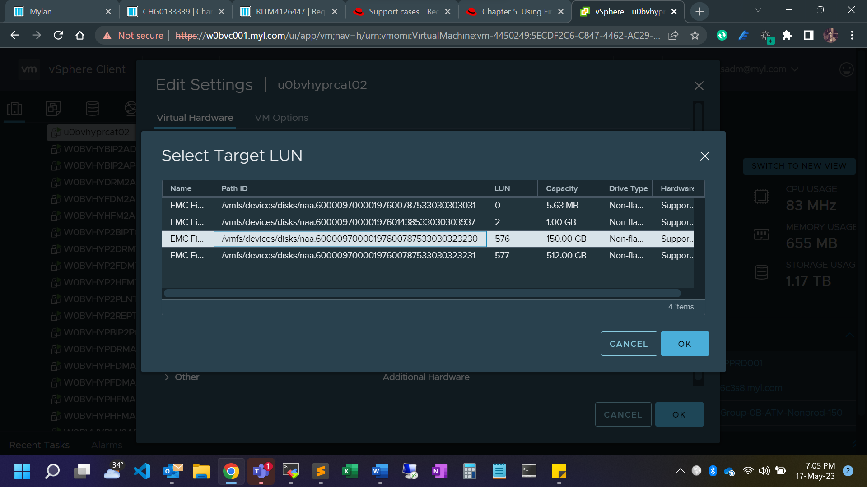
- Set the remaining options as per the below screenshot.
Note: Disk mode: Dependent for snapshot to work on RDM disks
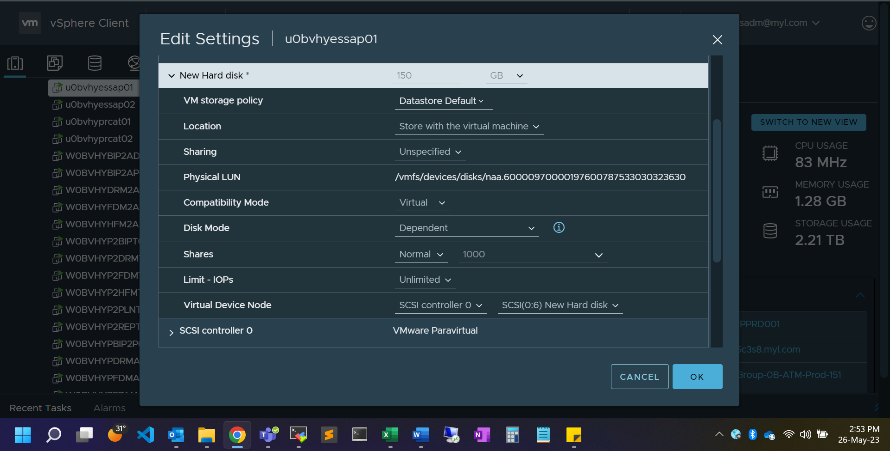

- Apply the recommendations from vCenter for storage placement
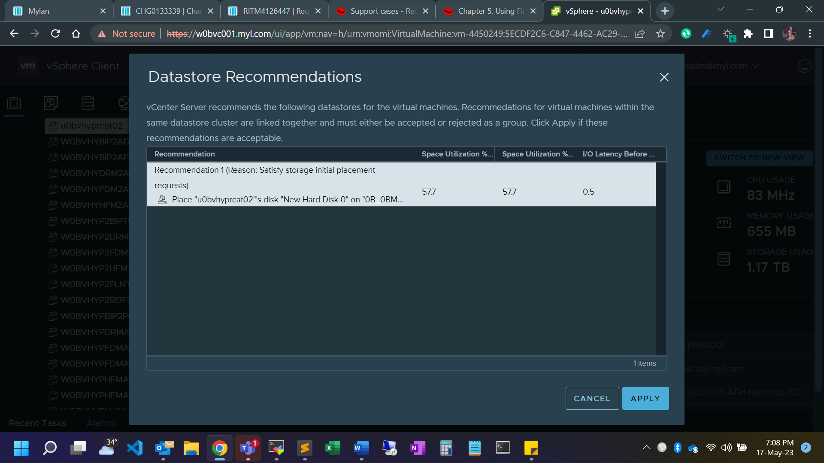
- Rescan SCSI hosts for the newly attached LUN to be visible on the server.
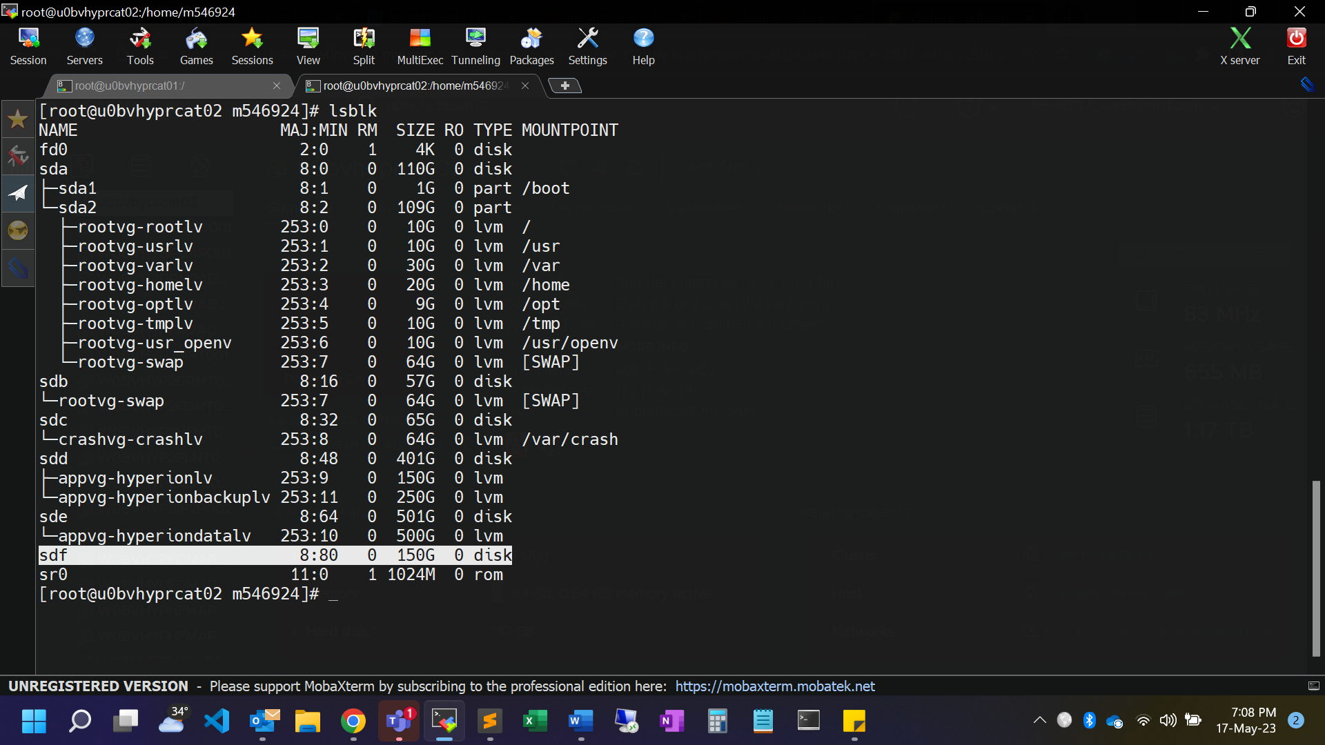

Roles and Responsibilities
Sl. No. | Roles | Responsibilities | Team Member Name
1. | Change Request | Respective Team / Unix Team | GIDC.unix_Run  GIDC.unix_Run@viatris.com
2. | Change Implementation | Respective Team / Unix Team | GIDC.unix_Run  GIDC.unix_Run@viatris.com

Escalation Matrix
Person Responsible | Role | Triggers When
Arun R  Arun.R@viatris.com  +91 9710677240 | Deputy Manager
Ashok Kumar R K  AshokKumar.RK@viatris.com  +91 9967735890 | Senior Manager
Zahir Hussain M ZahirHussain.M@viatris.com  +91 9840689462 | Senior Manager

6. Revision History

Date | Version | Summary of Changes | Author | Approved by
July 06 2025 | V1.0 | Created the Document | Benesh Selva Nesan P | Arun R
April 28 2026 | V1.1 | Validated the Document | Benesh Selva Nesan P | Arun R

